**Problem Statement :Online Bus Reservation System**

**ADMIN:**

**Step 01:Start**

**Step 02:Create an admin panel.**

**Step 03:Verify the bus documents**

**Step 04:Add the bus details, Delete the bus details, Update the bus details and View the details by using an individual bus id.**

**Step 05:Add the bus route, Update the bus route, Delete the bus route after adding bus details.**

**Step 06:Admin can Add the customer details, Update the customer details, Delete the customer details .**

**Step 07:Add the driver and cleaner details, Update the driver and cleaner details, Delete the driver and cleaner details.**

**Step 08:Stop**

**User:**

**Step 01:Start.**

**Step 02:Create an Account .**

**Step 03:User registration and add the username and phone number,age.**

**Step 04:Click the login button.not valid return to go to Step 3.**

**Step 05:User the search the bus in details**

**Step 06:User check the condition Proper Pickup.drop Proper location,rating,Customer Review .**

**Step 07:Users can book the bus. If they cancel by using the bus ticket, they can send information, chat and email and phone .**

**Step 08:Next Click the payment Option.pay the ticket fare sent to the information admin panel.**

**Step 09:User the Review the option**

**Step 10:User Travel history past and upcoming mention the option.**

**Step 11:Stop**

**Flow Chart:**

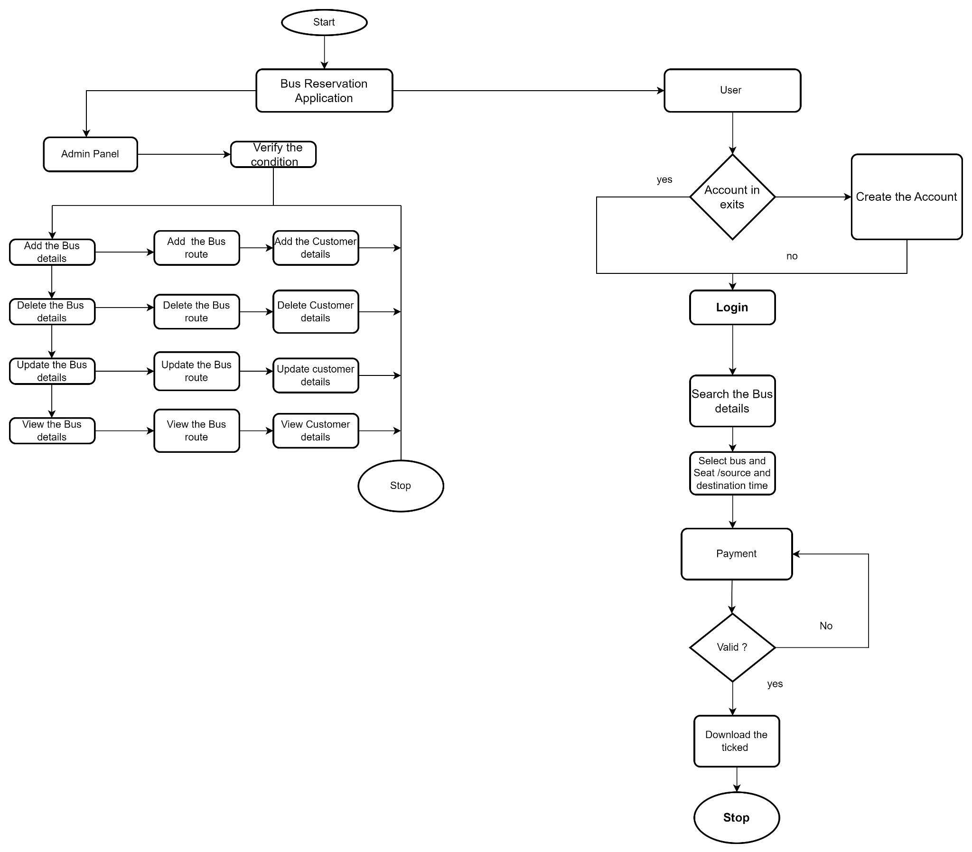

**Class Diagram:**

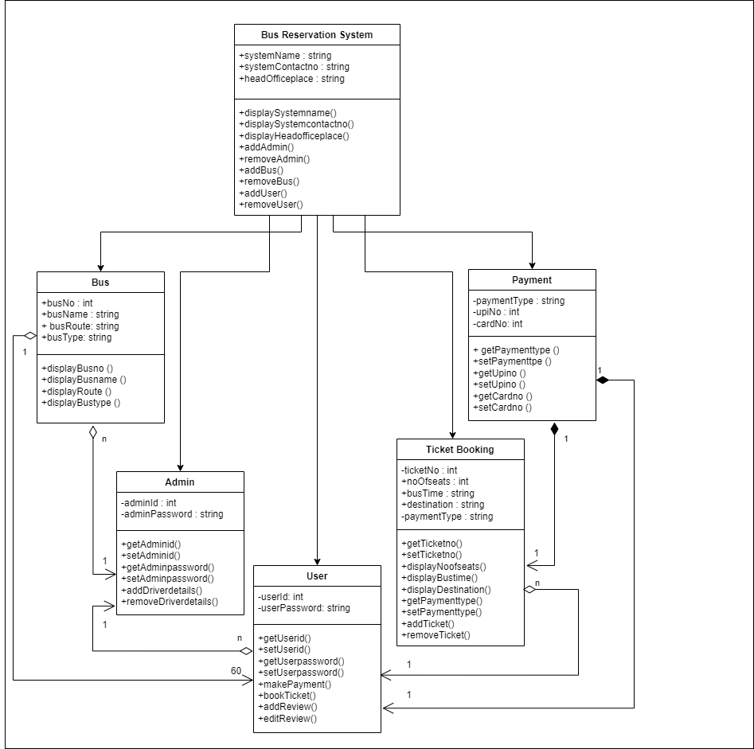

**UseCase Diagram:**

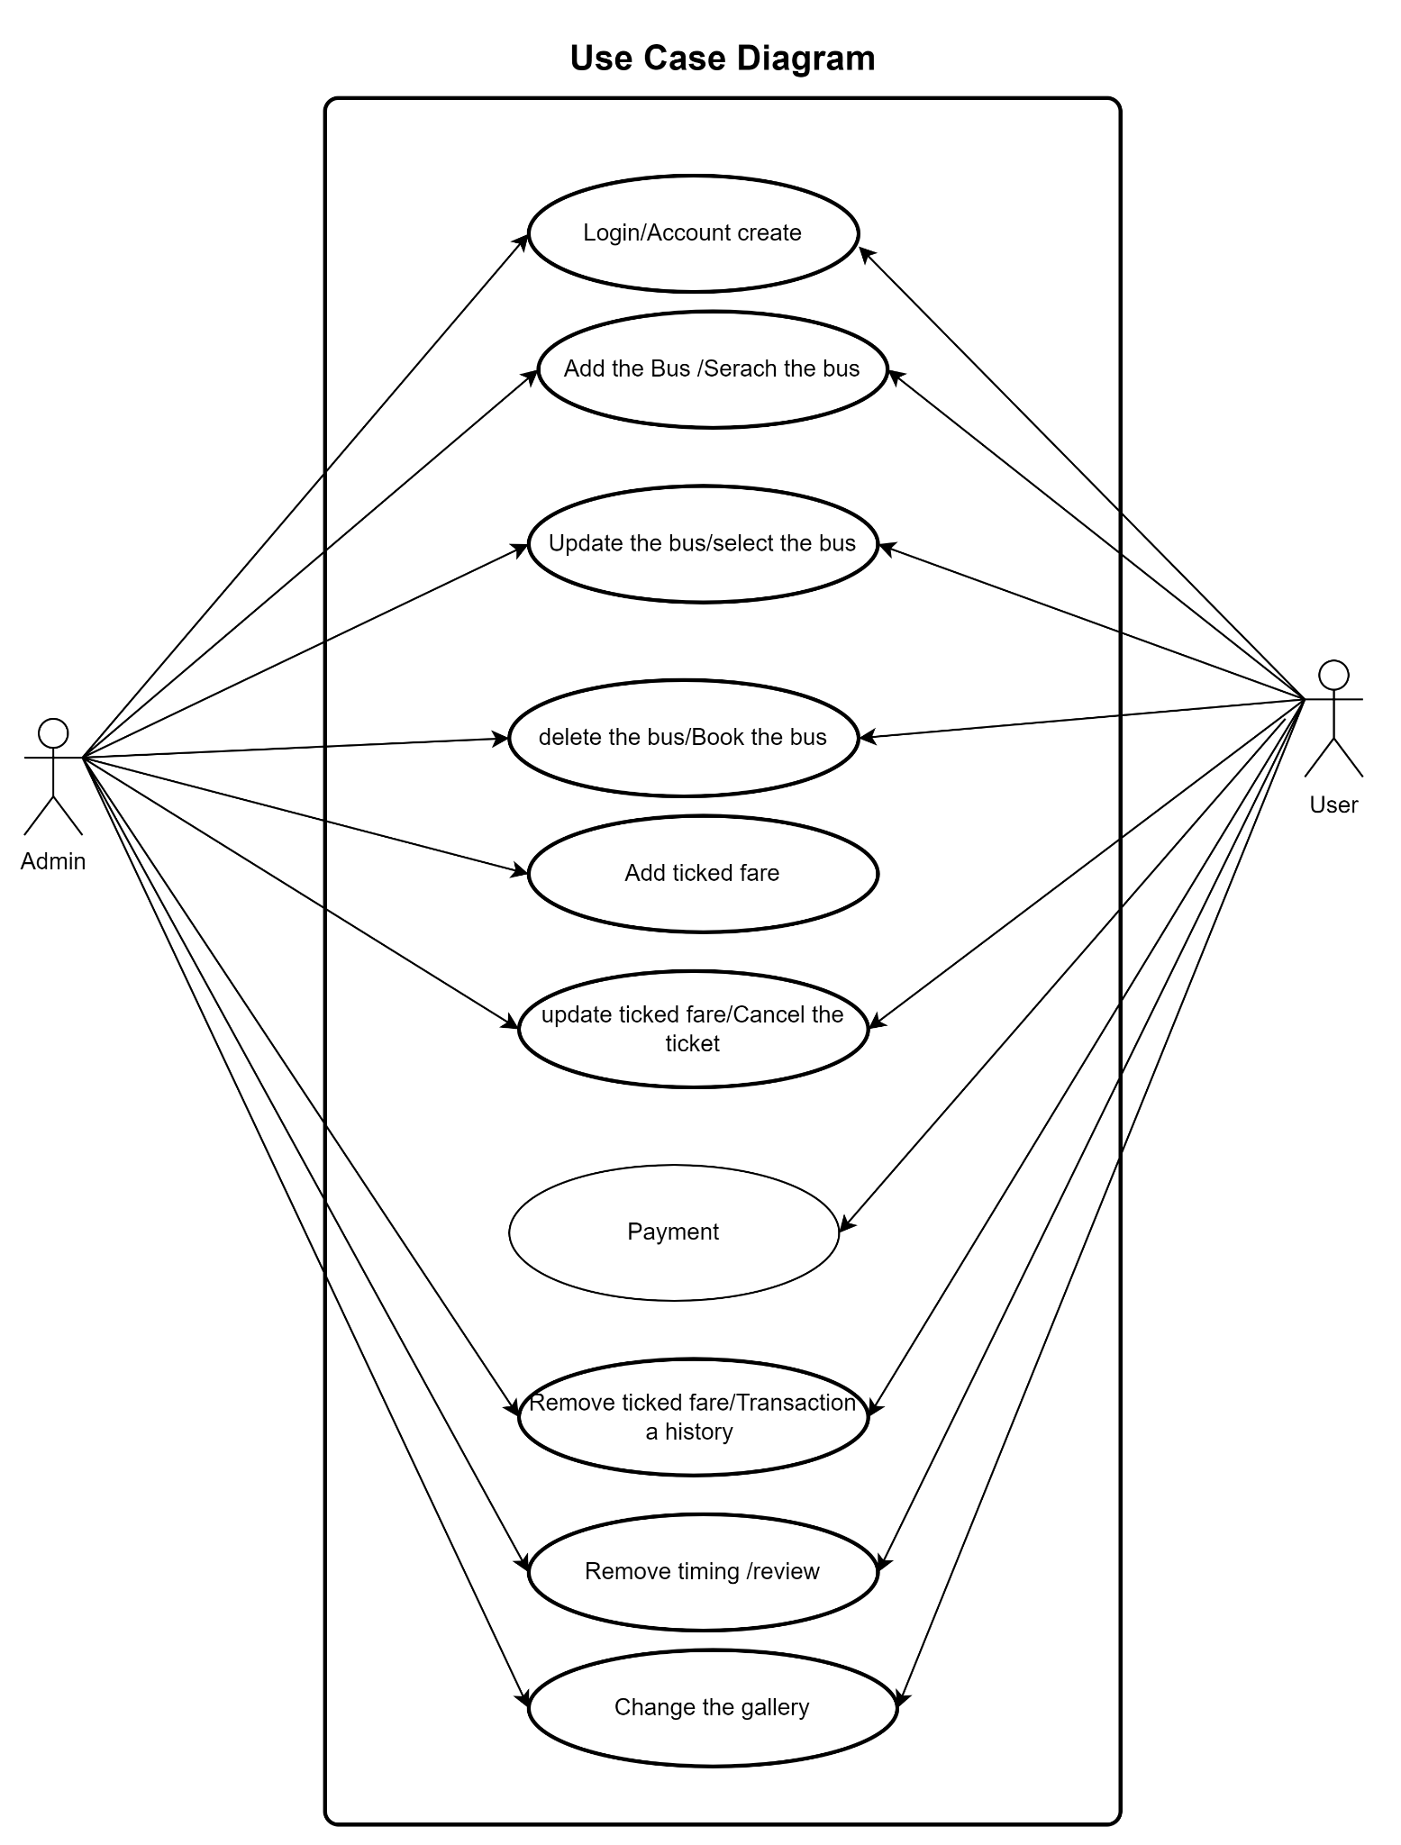

Sequence Diagram:

